Jana Nash-Siegle
ASL – 021601
November 7, y

Project/App Title:
Healthy List

Project/App Summary:
This app will allow for creation of a grocery list and each item can be edited, updated or deleted. User will be able to register via the app or login with facebook.

Twist:
You will not only be able to create/edit/save the list but multiple lists can be saved.

Create 4-week progress schedule and show featured that will be completed every week.

Example:

Week 1 Schedule:
Monday-Tuesday: Research / Class Basics
Wednesday-Thursday: Development Environment SetUp/ PRD / Preliminary “Hello World” completion. | Begin 2nd Week Development Bootstrap
Friday-Sunday Continue Code Development (HTML/CSS etc), Database Completed
Week 1 Deliverables:
PRD and Laravel Installed | Tested | Beginning Project Uploaded to GitHub

Week 2 features:
Login – User can create account, login to account and logout from account. (1)
Add Facebook login (2)
BootStrap (3)

Week 2 Schedule:
Mon-Sat - Layout Pages with Bootstrap/Base | Login/SignUp | Begin CRUD | Code Code Code
Sunday: Turn in Deliverables

Week 3 features:
CRUD – Create List, Add Items to List, Delete Items from List (4)

Week 3 Schedule:
Complete any unfinished work from Week 2.
Begin List Creation | Edit | Deletion | Save multiple lists

Week 4 features:
Password Reset (5)
Jquery Plugin (6)

Week 4 Schedule:
Complete any unfinished work from previous weeks.

Project Specs:
Landing Page
LogIn Page
Register Page
User Page
User Information
Grocery List Page
Create, Update and Delete within list.

Wire Diagrams:

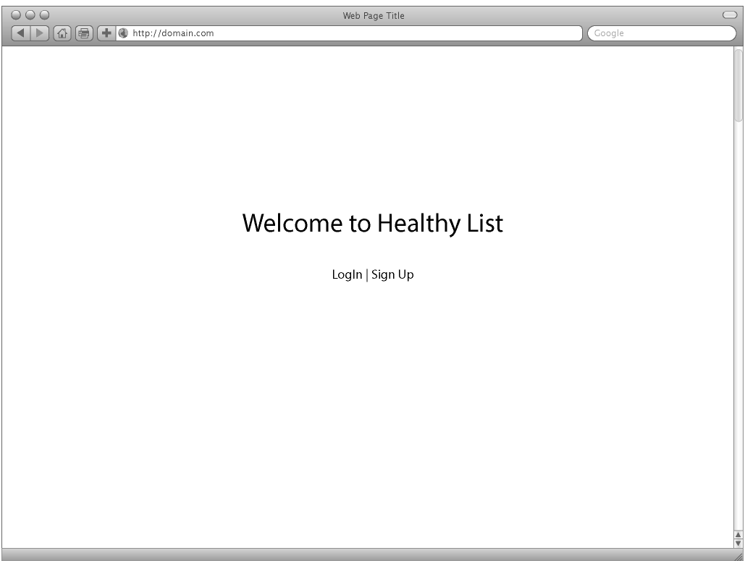
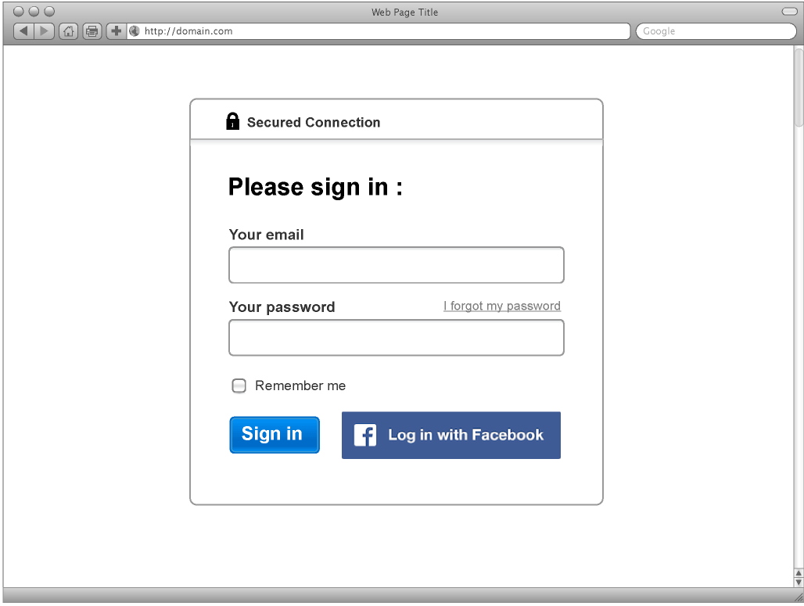

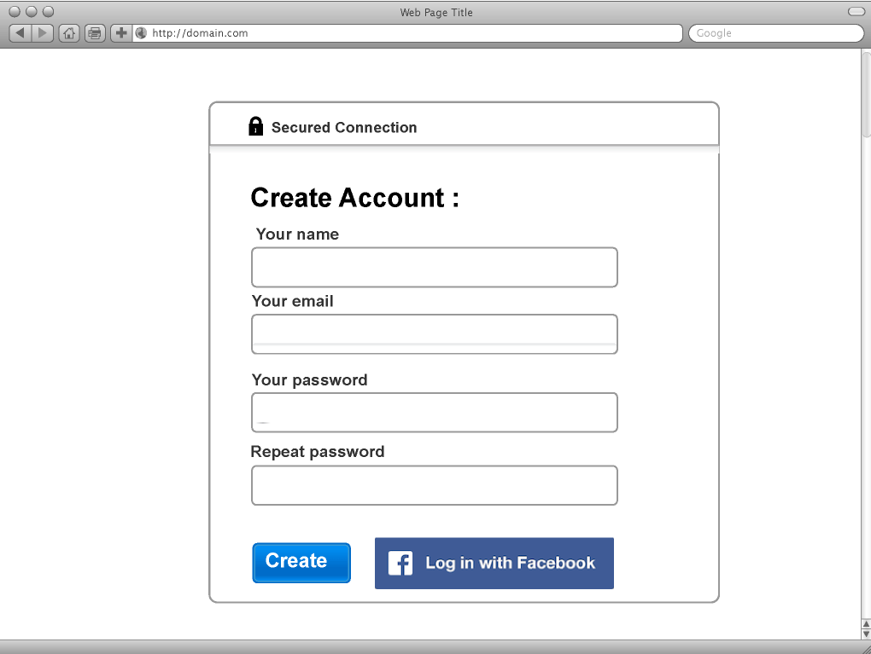

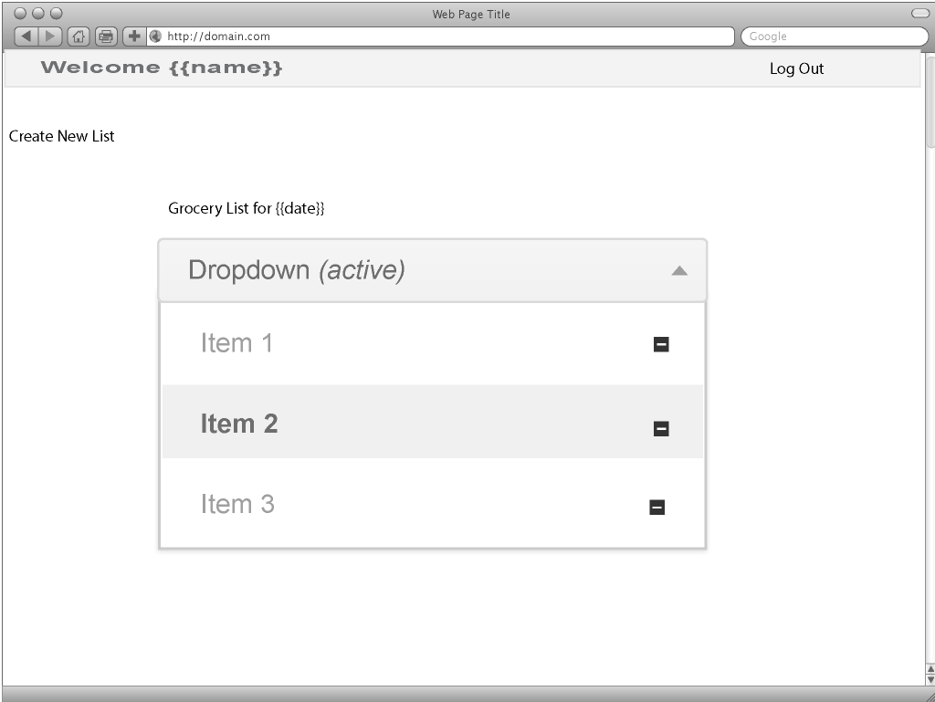

Color Scheme:

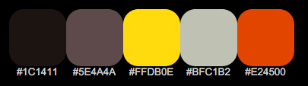

Database Diagram:

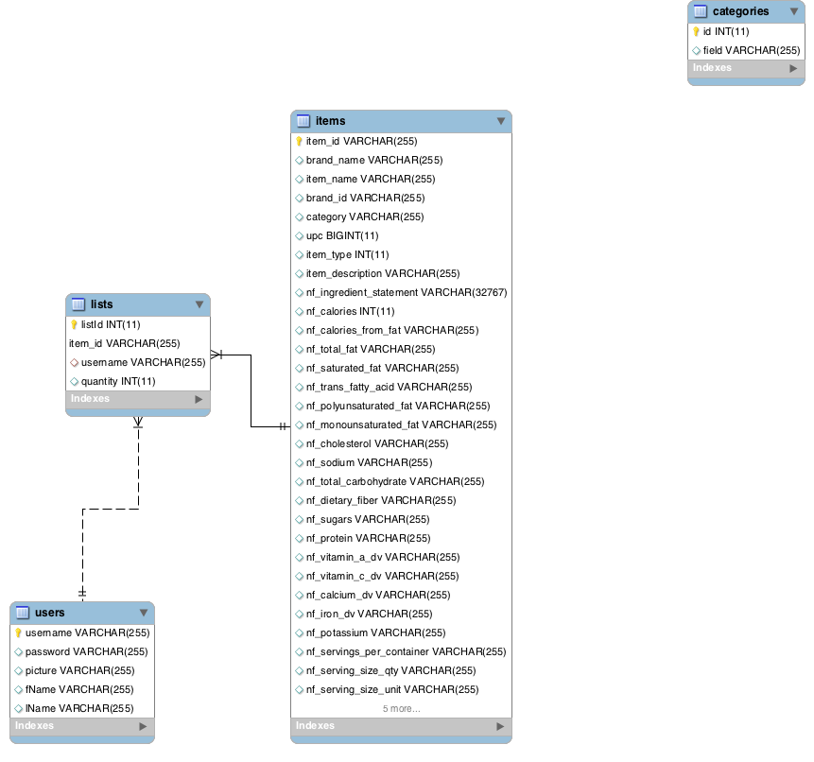
Language and framework:
PHP and Laravel and Bootstrap.

Version one:
Use of a jquery plugin | bootstrap layout, CRUD, login and facebook option for login, Search, Reset Password, internal database for form data

Version two:
If I could extend this program it would be to add the ability to gather nutritional information about items, locate closest places to purchase items, add authentication to keep lists private according to logged in user.

